HUMS 027/LITR 027
Six Pretty Good Selves

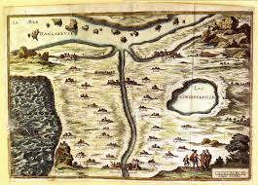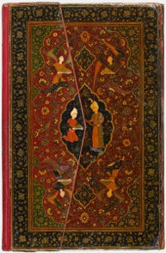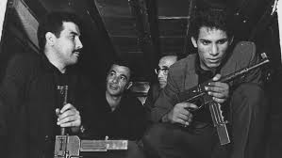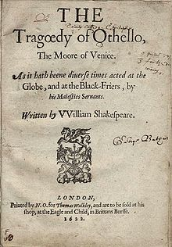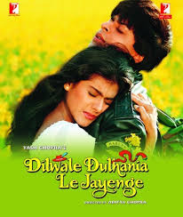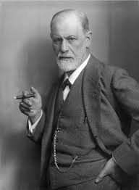

Fall 2021
M/W 9:00-10:15 + Lab: F 12:30-3:30

Marta Figlerowicz & Ayesha Ramachandran

Course Description

Through the prism of thinking about the self, this course provides first-year students with an intensive introduction to studying the humanities at Yale. The course is anchored around six trans-historical models of thinking about selfood: the ideal self, the lover, the revolutionary, the convert, the solipsist, and the social
climber. We range widely across genres, media, periods, and geographies: from Plato's Symposium to Zora Neale Hurston’s Barracoon, from the ghazals of Hafez to the Kamasutra. We also make extensive use of Yale's rich special collections and art galleries and devote sustained attention to improving students' academic writing skills. This is a 1.5 credit intensive writing course that fulfills one WR requirement. Friday sessions will alternate between writing workshops, virtual field trips to
Yale collections, and (when possible) in person small-group meetings outdoors with the instructors.

Texts

Plato, Symposium, ed. & trans. Nehamas and Woodruff (Hackett)

Vatsyayana, Kamasutra ed. and trans. Doniger and Kakar (Oxford World’s Classics)

Shakespeare, Othello (Pelican Shakespeare)

Augustine, Confessions (Oxford World’s Classics)

Zora Neale Hurston, Barracoon

Tobias Hecht, After Life

Jane Austen, Pride and Prejudice (Penguin)

All materials marked “Online” will be available via Canvas. We urge you to use them in a format where you can make annotations.

***

Weekly Schedule

Week 1: Introductions

1 Sept: What is the Self and are we losing it?
John Donne, “The Good Morrow”
Isabel Wilkerson, from Caste

3 Sept: Plato, Symposium

- The Ideal Self

Week 2:

7 Sept: LABOR DAY

9 Sept: Plato, Symposium

11 Sept: Writing goals; introduction to Yale Libraries.
Short Paper #1 Due

Week 3:

13 Sept: Vatsyayana, Kamasutra, Book 1; read Table of Contents carefully

15 Sept: Vatsyayana, Kamasutra, Books 4 and 6

17 Sept: Writing Workshop/Collections Visit TBA

- The Lover

Week 4:

20 Sept: Petrarch, selections from Rerum vulgarium fragmenta (Online)
Louise Labé, from Sonnets (Online)
Skills Essay Due

22 Sept: Selections from Hafez’s Diwan and Jahan Malek Khatun’s poems (Online)

24 Sept: Writing Workshop/Collections Visit TBA

Week 5:

27 Sept: Shakespeare, Othello, Acts 1-3
Short Paper #2 DUE (in-class)

29 Sept: Shakespeare, Othello, Acts 4-5

1 Oct: Writing Workshop/Collections Visit TBA

Week 6:

4 Oct.: Jenkins, Moonlight (2016)
Midterm Essay Draft Due

6 Oct: Kobayashi, The Human Condition, Vol. 1 (1959)

8 Oct: Writing Workshop
Peer Review for Midterm Essay Drafts

- The Convert
- The Revolutionary

Week 7:

11 Oct: Pontecorvo, The Battle of Algiers (1966)

13 Oct: Fanon, “Algeria Unveiled”; excerpts from Black Skin, White Masks and The Wretched of the Earth (online)

15 Oct: Writing Workshop/Collections Visit TBA

Week 8:

18 Oct: Narrative of the Life of Walatta Petros (online)

MIDTERM ESSAY DUE

20 Oct: FALL BREAK

23 Oct: FALL BREAK

Week 9:

25 Oct: Augustine, Confessions

27 Oct Augustine, Confessions

29 Oct: Writing Workshop/Collections Visit TBA
*Start keeping Dream Journal*

Week 10:

1 Nov: Zora Neale Hurston, Barracoon
Skills Essay #2 (in-class)

3 Nov: Alice Walker, “Looking for Zora”

6 Nov: Writing Workshop/Collections Visit TBA

5. The Solipsist

Week 11:

8 Nov: Freud, from Interpretation of Dreams (online)

10 Nov: Saint Ignatius of Loyola, from Spiritual Exercises (online)
Descartes, from Meditations (online)

12 Nov: Writing Workshop/Collections Visit TBA

Week 12:

15 Nov: A’ishah al-Ba’uniyyah, from Principles of Sufism and Poems (online)
Short Paper #3 Due

17 Nov: Hecht, After Life

20 Nov: NO LAB

** 19-28 Nov: Thanksgiving Break **

6. The Social Climber

Week 13:

29 Nov: Jane Austen, Pride and Prejudice
Final Paper Prospectus Due

1 Dec: Emma Goldman, The Traffic in Women (online)

3 Dec: Writing Workshop/Collections Visit TBA

Week 14:

6 Dec: Chopra, Dilwale dulhaniya lejaaynge (1995)

8 Dec: Panahi, Crimson Gold (2003)

10 Dec: Writing Workshop
Draft of Final Paper Due
Peer Review for Final Paper Drafts

20 Dec: FINAL PAPER DUE
WRITING PORTFOLIO DUE with Self-Assessment

***
Course Policies and Requirements

A. Papers with required drafts: You will write two papers for this course, one mid-term essay of 5-7 pages and a final essay of 10-12 pages in length. You will turn in required drafts for each essay and will go through a peer review process. See schedule for due dates!

B. THREE Short Assignments: You will write three creative OR critical short papers (500-750 words). More information to follow in class. See schedule for due dates!

C. TWO short “skills” essays: You will do 2 short 500-word skills essays to practice aspects of paper-writing in preparation for your papers. See schedule for due dates!

D. Writing Portfolio: You will keep a writing portfolio of ALL your written assignments and revisions over the course of the semester. This will be submitted at the end of the term with a self-reflection on your growth as a writer.

E. Participation & Required Chat: To enable everyone to participate consistently throughout the semester, you will be required to post weekly responses to the class chat forum: details to follow! These will count towards your participation grade.

Requirements for written assignments: We expect all written assignments to be typed in a regular 12-point font, with 1-inch margins, proofread and carefully revised. Sloppy work is a mark of disrespect to all of us and we urge you to avoid it. You will be penalized for persistent technical errors (spelling mistakes, large font, short length etc.) up to a third of a letter grade (i.e. if you would get a B+, you will get a B instead).

II. Grades
The grading structure for the course is as follows:
Participation: 15%
Short Papers (5): 25%
Midterm Paper: 25%
Final Paper: 35%
For an explanation of grades, see “Grading Rubric” (handout and online)

III. Class Resources
The online site for this course will contain a number of supplementary materials to help you enrich your understanding of the topic, its key philosophic questions, and major literary responses. Please check the site regularly.

IV. Your Responsibilities

Attendance: This course will rely on lively interchange: therefore attendance and full participation are required synchronously. This means having read the texts and watching the films carefully before you come to class, having some specific responses to them that you are willing to share, being sufficiently alert to join in a lively conversation, and being willing to participate in readings and exercises. More than 4 unexcused absences will result in a lower grade for the course. After 6 absences, you will receive an F. Active participation is a significant component of your grade. To make the discussion useful and enjoyable for all of us, we will expect you to have done the reading and posted a comment in a timely manner. If you have to miss a class, please email us beforehand to let us know.

Lateness is disruptive and disrespectful to all of us, so please make sure you get to class on time.

Communication: You are required to check your school email. From time to time, we will send out emails to you and the class: you are responsible to ensure that we have the correct email for you!

Meeting with us: We have (virtual) office hours so that we can talk to you outside of class time: make an appointment with us at least once this semester!

V. Miscellaneous Policies

Extensions and Late Work: We’d like to get comments back to you as soon as possible, but can only do this if we receive your work promptly. We are not unreasonable, so please email us if circumstances hinder you from finishing an assignment on time. Do not email us for an extension the night before, unless you have an officially sanctioned excuse or a very creative explanation. Extenuating circumstances we understand and tolerate; procrastination we understand but do not tolerate or encourage. A good paper takes time and forethought! Late assignments will be penalized by a third of a letter grade per day (one day late=highest possible grade of A-; two days late=B+, etc.).

Plagiarism: Yale considers plagiarism, or academic dishonesty of any kind, a serious offense. To us, it is the worst offense you can commit in an academic context: it is disrespectful not only to your source, but to your own intellectual integrity. Forms of plagiarism include submitting papers, or portions of papers, written by other people as your own, as well as presenting someone else’s ideas as your own without acknowledging the source. You are responsible for understanding what constitutes academic dishonesty and avoiding it. We encourage you to review the following resources so that you understand what exactly constitutes plagiarism – when in doubt, or if you have questions, don’t hesitate to talk to us:
http://yalecollege.yale.edu/content/cheating-plagiarism-and-documentation
http://owl.english.purdue.edu/owl/resource/589/01/
http://hnn.us/articles/514.html

