Culture and Human Evolution Gary Tomlinson
HUMS 336/E&EB336/HSHM 453 Spring 2020 Tuesday 1:30-3:20

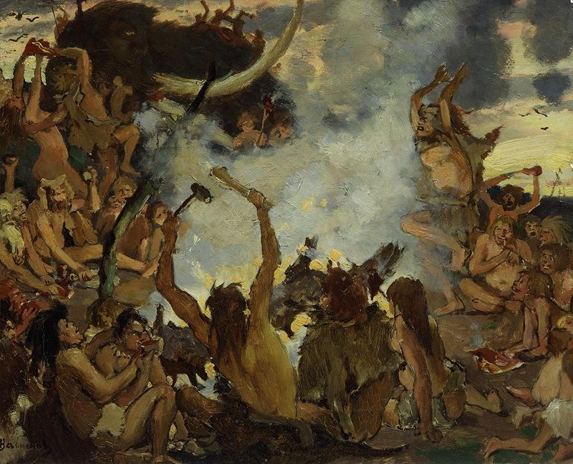
--Viktor Vasnetsov, A Stone Age Feast, 1883

This course examines the origins of human modernity in the light of evolutionary and archaeological evidence. Its aim is to understand, through a merger of scientific reasoning with humanistic theory, the impact of human culture on natural selection across the last 250,000 years.
Culture and Human Evolution
In recent years, the so-called "extended synthesis" of evolutionary theory has opened new opportunities for incorporating ideas of culture into evolutionary reasoning about human origins. Evolutionists have mostly modeled this biocultural emphasis in quantitative terms, and they have been slow to exploit humanistic, qualitative approaches. This seminar will take up the challenge of bringing such qualitative approaches to bear on our speculations about our biocultural emergence. The course will fall into four parts: We will begin (weeks 1-4 on the attached calendar of readings) by sampling, through representative readings from Darwin and modern evolutionists, the thinking that has led to the extended evolutionary synthesis. In weeks 5 and 6 we will examine this new view and explore approaches to the modeling of cultural selection that evolutionists have thus far offered. Next, in weeks 7-9, we will turn to the new opportunities afforded by the admixture of humanistic theory, especially semiotic theories of perception and experience that can model hominin culture and locate it in the context of other animal cultures. This, finally, will allow us, across the last four weeks of class, to join evolutionary modeling with recent archaeological evidence to construct a new model of human emergence.

Calendar of readings:
F = See the Files section of the class server
O = online book available from Yale library
J = E-journal article available through library

January 14: Week 1: Introduction

January 21: Week 2:
(Wikipedia article “Evolution,” sections 1-5.)
Richard Lewontin, “Not So Natural Selection,” New York Review of Books, May 27, 2010; at: http://www.nybooks.com/articles/2010/05/27/not-so-natural-selection/
Kevin Laland, Gregory A. Wray, et al., “Does Evolutionary Theory Need a Rethink?” Nature October 8, 2014; at: https://www.nature.com/news/does-evolutionary-theory-need-a-rethink-1.16080
Elisabeth Anne Lloyd, “The Nature of Darwin’s Support for the Theory of Natural Selection,” Philosophy of Science 50 (1983), 112-29. J

January 28: Week 3:
Charles Darwin, On the Origin of Species, introduction, chaps. 1-4, 6.
[https://archive.org/details/onoriginofspec00darw]
[http://darwin-online.org.uk/converted/pdf/1861_OriginNY_F382.pdf]

February 4: Week 4:
Charles Darwin, On the Origin of Species, chaps. 7 and 14.
Richard Lewontin, The Triple Helix: Gene, Organism, and Environment (Cambridge MA: Harvard University Press, 2000), pp.41-68. F
Massimo Pigliucci and Jonathan Kaplan, Making Sense of Evolution: The Conceptual Foundations of Evolutionary Biology (Chicago: University of Chicago Press, 2006), chap. 5. O

February 11: Week 5:
Kevin N. Laland, Tobias Uller, Marcus W. Feldman, Kim Sterelny, Gerd B. Müller, Armin Moczek, Eva Jablonka, and John Odling-Smee, “The Extended Evolutionary Synthesis: Its Structure, Assumptions and Predictions,” Proceedings of the Royal Society B 282 (2015) 20151019; at: http://dx.doi.org/10.1098/rspb.2015.1019. J
Manfred Laubichler and Jürgen Renn, “Extended Evolution: A Conceptual Framework for Integrating Regulatory Networks and Niche Construction” F
Gary Tomlinson, Culture and the Course of Human Evolution, preface, chaps. 1 and 2

February 18: Week 6:
Tomlinson, Culture and the Course of Human Evolution, chap. 3
F. John Odling-Smee, Kevin N. Laland, and Marcus W. Feldman, Niche Construction: The Neglected Process in Evolution (Princeton: Princeton University Press, 2003), chap. 6, pp.239-64. O

Short essay due.

February 25: Week 7
Tomlinson, Culture and the Course of Human Evolution, chap. 4
Terrence Deacon, “Beyond the Symbolic Species” In The Symbolic Species Evolved, ed. Theresa Schilhab, Frederik Stjernfelt, and Terrence Deacon (Berlin: Springer Verlag, 2012), pp.9-38 F

March 3: Week 8:
Michael Tomasello, M. Carpenter, J. Call, T. Behne, and H. Moll, “Understanding and
Sharing Intentions: The Origins of Cultural Cognition,” Behavioral and Brain Sciences 28 (2005) 675–91. J
Michael Tomasello, Origins of Human Communication (Cambridge: MIT Press, 2008), chap. 7. O
Merlin Donald, “Preconditions for the Evolution of Protolanguages,” in The Descent of Mind: Psychological Perspectives on Hominid Evolution, ed. Michael C. Corballis and Stephen E. G. Lea (Oxford: Oxford University Press, 1999), pp. 138–54. O

March 10, 17: Spring recess

Short essay due, concerning Robert Boyd and Peter J. Richerson, The Origin and Evolution of Cultures (New York: Oxford University Press, 2005), excerpts TBD O

March 24: Week 9:
Tomlinson, Culture and the Course of Human Evolution, chap. 5
Sergio Balari and Guillermo Lorenzo, Computational Phenotypes: Towards an Evolutionary Developmental Biolinguistics (Oxford: Oxford University Press, 2013), chap. 5. O

March 31: Week 10
Tomlinson, Culture and the Course of Human Evolution, chap. 6, pp.115-28.
Chris Stringer, “The Origin and Dispersal of Homo sapiens: Our Current State of Knowledge,” in Rethinking the Human Revolution (Cambridge: The McDonald Institute, 2007), pp.5-15. F
Sally McBrearty, “Down with the Revolution!” in Rethinking the Human Revolution, ed. Mellars et al., pp.133-52. F
Nicholas Conard, “Cultural Evolution in Africa and Eurasia During the Middle and Late Pleistocene,” in Handbook of Paleoanthropology, ed. Winfried Henke and Ian Tattersall (3 vols., Berlin: Springer Verlag, 2007), 3:2001-37. O

April 7: Week 11
Tomlinson, Culture and the Course of Human Evolution, chap. 6, pp.128-45.
Cavalli-Sforza, L. Luca, and Marcus W. Feldman. 2003. “The Application of Molecular Genetic Approaches to the Study of Human Evolution.” Nature Genetics Supplement 33 (2003), 266-75. F
Sarah S. Richardson, “Race and IQ in the Postgenomic Age: The Microcephaly Case,” BioSocieties 6:420-46. F

April 14: Week 12
Tomlinson, Culture and the Course of Human Evolution, chap.7. F
Jürgen Renn, The Evolution of Knowledge, chap. __.
Dylan van der Schyff and Andrea Schiavio, “Evolutionary Musicology Meets Embodied Cognition: Biocultural Coevolution and the Enactive Origins of Human Musicality,” Frontiers in Neuroscience 11 (Sept. 2017), Article 519 (doi: 10.3389/fnins.2017.00519) J

April 21: Week 13
Recent developments in Neandertal and early H. sapiens research; see F, under:
Neandertal art 2018
Neandertal artists
Moroccan sapiens 300kya
Homo sapiens in Arabia 85kya
Humans in Australia 65kya

Final essay due (date TBA).

My office: Director’s Office, Whitney Humanities Center, 53 Wall Street, 1st floor
My office hours: Wednesdays 2:00-4:00 or by appointment

