War and Its Literature
HUMS 318
Spring 2020

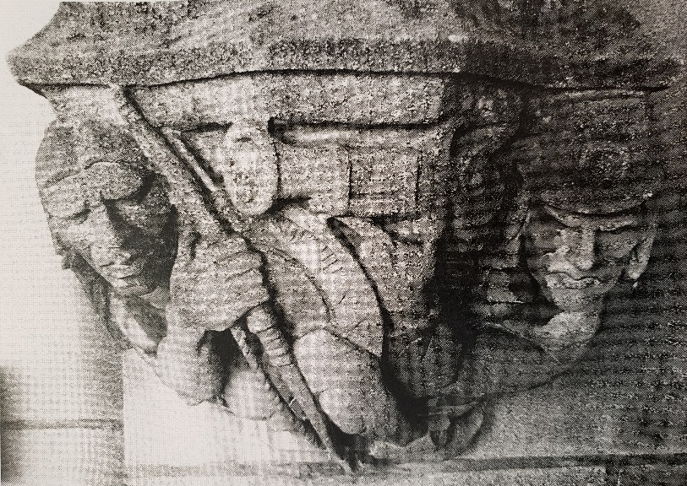

War is the first of “The Four Horsemen of the Apocalypse.” A pre-Socratic fragment attributed to Heraclitus declares war to be “the father of all things,” General William Tecumseh Sherman, who loved it, said, “War is Hell.” All have a claim to be correct.
What is clear is that war has supplied humanity’s symbols, similes, and language references from college football’s “Fighting Irish” to “The War on Poverty.” War also figures in the first tier of literature and all other liberal arts. An entire publishing genre has existed to advise corporate CEOs on how to follow the strategies of Sun Tzu’s The Art of War.
Uniquely, the starting points for our study of war will, as the attached syllabus displays, be grounded in literature, in novels of wartime societies, cultures, and situations which reveal that the phenomenon of war affects nations and peoples in their entireties, not just in the outcomes of combat on the battlefield although these will be covered in the texts to be read as well. Each book assigned will, in class, be set in the context of a major war and its various scholarly-historical interpretations, and an extensive bibliography will offer notable non-fiction works on the roster of conflicts to be considered during the semester. The place of warfare in intellectual and moral history will also be depicted in the monuments of, inter alia, Les Invalides, Yasukuni, Trafalgar Square, the Vietnam Veterans Memorial and Woolsey Hall.
For the Humanities, the arena of knowledge which uniquely takes uncertainty to be its province, war is an innate topic of study. As General, later President, Eisenhower observed, in preparing for battle, “All plans are useless, but planning is essential” – which could be the motto for this seminar. The syllabus reveals that to a significant extent every major era in intellectual and political history can only fully be understood by investigating the war or wars that lie at its core – for better or worse.
War and its Literature
Syllabus
Spring 2020

I and II. War in the Human Condition
Simone Weil, “The Iliad or the Poem of Force”
Herodotus: Marathon, Thermopylae, Salamis. Xenophon, The Persian Expedition (“The March up Country”) and Watership Down
Thucydides, The Peloponnesian War
Polybius on The Camp and The Password
Caesar’s Gallic War and assassination

III. Joan of Arc
George Bernard Shaw. Saint Joan
Shakespeare, King Lear, Act 1, Scene 1

IV. The Thirty Years’ War
Gustavus Adolphus
Hugo Grotius, On the Law of War and Peace

V. King Philip’s War
Douglas Leach, Flintlock and Tomahawk
Lisa Brooks, A New History of King Philip’s War (Our Beloved Kin)

VI. The American Revolution
James Fenimore Cooper, The Last of the Mohicans
Robert Graves, Sergeant Lamb’s America

VII. The Civil War
James McPherson, Why the Civil War Still Matters.
Tom Carhart, Lee’s Real Plan at Gettysburg.
William Faulkner, “For Every Southern Boy…”

VIII. The Indian Wars
Custer’s Last Stand.
Pekka Hämäläinen, The Comanche Empire

IX. The Chinese Civil War
Andrei Malraux, Man’s Fate

X. World War II
J.G. Ballard, Empire of the Sun

XI. The Arab-Israeli Conflict
Muriel Spark, The Mandelbaum Gate

XII. The Vietnam War
Charles Hill, “Fighting Stories”; “On Ken Burns’ The Vietnam War”

XIII. Richard Wilbur, “Round About a Poem of Housman’s” The National Mall, Washington, D.C.
War and its Literature
Required Books

- George Bernard Shaw, Saint Joan. Penguin Classics, 2003 (1924).
ISBN: 13: 978-0-140-43791-1

- Douglas Edward Leach, Flintlock and Tomahawk: New England in King Philip’s War. Countryman Press, 2009.
ISBN: 13: 978-0-88150-8857

- Robert Graves, Sergeant Lamb’s America. Academy Chicago, 1995 (1940).
ISBN: 0-89733-213-X

- Tom Carhart, Lost Triumph: Lee’s Real Plan at Gettysburg. Berkeley, 2006.
ISBN: 0-399-15249-0

- Pekka Hämäläinen, The Comanche Empire. Yale University Press, 2008.
ISBN: 978-0-300-15117-6

- Andrei Malraux, Man’s Fate. Penguin Classics, 2009 (1924).
ISBN: 13: 978-0-14119098-3

- J.G. Ballard, Empire of the Sun. Pocket Books, Washington Square, 1984.
ISBN: 0-671-53053-4

- Muriel Spark, The Mandelbaum Gate, Virago Press, 2013.
ISBN: 13: 978-1844-0-8966-6

War and its Literature
Course Reader Contents

- Simone Weil, “The Iliad on the Poem of Force”
- Byron, “The Isles of Greece”
- Mary Renault, The Last of the Wine
- Xenophon, The Persian Expedition (The March Up Country)
- Richard Adams, Watership Down
- Polybius: Fabius Maximus; The Camp; The Password
- Plutarch, “The Death of Caesar”
- King Lear, Act I, Scene I
- Lisa Brooks, A New History of King Philip’s War
- Gustavus Adolphus, “The Beginning of the Thirty Years’ War”
- Grotius, The Law of War and Peace
- Philip Fisher, on The Leatherstocking Tales
- Sun Tzu, The Art of Warfare: Terrain and Ground
- James McPherson, Why the Civil War Still Matters
- William Faulkner, “For Every Southern Boy…”
- Richard Hillary, “The Invaders” (The Battle of Britain)
- Charles Hill, “Fighting Stories”; “On Ken Burns’ Vietnam War”
- Richard Wilbur, “Round About a Poem of Housman’s”

