Classical Storytelling in the Modern World

HUMS 073

Fall 2021 (Subject to Revision)

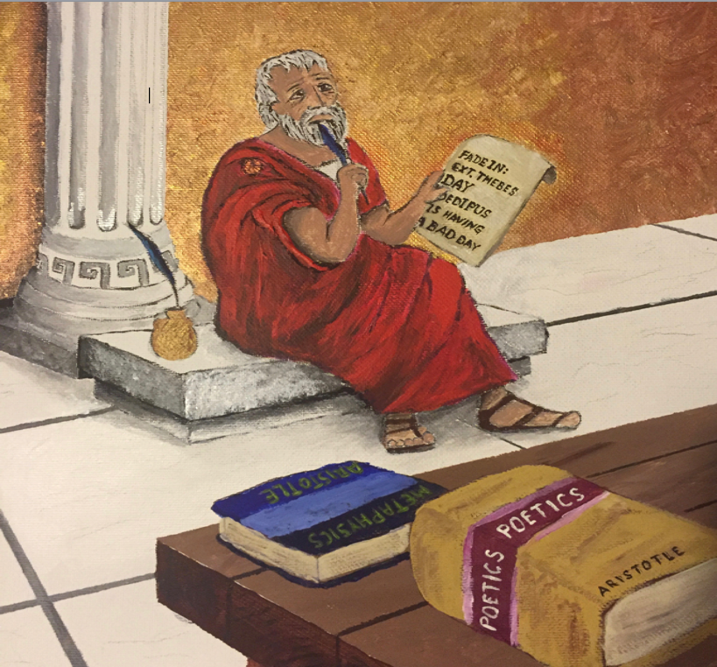

Course Meetings: T,Th 2:30pm – 3:45pm

Location: TBD

Instructor: Prof. Brian Price

Contact: brian.price@yale.edu

Office Hours: by appointment on Zoom or dining hall

Credit Hours 1 Semester Credit Hours
Prerequisites None. Open only to first-year students.

Course Description:
Since we first arrived on the planet and sat around the cave fire telling the tale of that morning’s great saber-tooth tiger hunt, we’ve been telling each other stories. In fact, one of the primary distinctions that separates us from all other animals and which connects each one of us as a species is that, regardless of our history, geography, or culture, we all tell stories. Why? Is it primarily an entertainment? Or is there some deeper biological or evolutionary imperative at work? Perhaps the answer lies somewhere in the fact that, when one examines the dramatic narratives that have stood the test of time, from Oedipus Rex to the most recent installment of the Marvel Cinematic Universe, one discovers that not only do we all tell stories, but we’ve been telling them in essentially the SAME WAY.
In his seminal work Poetics, Aristotle first identified the observable patterns and recurring elements that existed in the successful tragedies and epic poems of his time, as he posed the existential query: Why do we tell stories? And his illuminating analysis and conclusions are still just as meaningful and relevant today in our contemporary dramatic narratives, our movies, plays, and Netflix binges-of-the-week.
In this seminar, we will examine Aristotle’s observations and conclusions and relate them to the contemporary dramatic narratives we consume and enjoy today. By doing so, we will identify the universal principles that all good stories share, investigate how these principles connect us all despite cultural, ethnic, and geographical differences, learn how to incorporate Aristotle’s precepts into our own creative expression and communications -- and most importantly, explore the vital function of storytelling, why we tell them, what makes a good one, and how to best tell one effectively.
Outcomes: Upon completion of this course students should be able to:
- Demonstrate a knowledge of classical theories of story, structure, and character (as elucidated in the writings of Aristotle, as well as Campbell, Vogler, and other modern theorists)
- Identify and analyze classical theories of dramatic narrative storytelling in post-classical usage
- Critically deconstruct a range of works of contemporary dramatic narrative in relation to Aristotle’s observations and analyses
- Utilize those principles in the student’s own creative expression

Select Bibliography: Primary Sources:

Poetics by Aristotle, trans. Malcolm Heath, (ISBN: 9780140446364, though ANY translation will do)
Classical Storytelling and Contemporary Screenwriting: Aristotle and the Modern Scriptwriter by Brian Price (ISBN: 978-1138553408)

Selected Plays, Teleplays, and Screenplays (TBD)

Secondary Sources (selections from):

The Power of Myth by Joseph Campbell with Bill Moyers (ISBN: 978-0385418867
The Writer’s Journey: Mythic Structure for Writers by Christopher
Vogler (ISBN: 978-1932907360
The Art of Dramatic Writing by Lejos Egri (ISBN: 978-0671213329)
Mythological Storytelling: Classic Stages of the Hero’s Journey (The Modern Monomyth) and The Hero’s Journey of Odysseus: A Monomyth Guide to the Iliad and Odyssey by Josh Coker

Course Schedule:

Week 1: (9/2) INTRODUCTION

COURSE OVERVIEW. The task before us. Assignments. Handouts. Dramatic narrative as “The Art of Telling Lies Skillfully.” Read Aristotle’s Poetics (any translation). (Additional reading: CS/CS, pgs. 3-16).

Week 2: (9/7,9/9) PREMISE
Why do we tell stories? Discuss Aristotle. Mimesis and Catharsis. Essential elements and definitions. Imitation of an action that is complete, whole, and unified. Plot, Character, Thought, Diction, and Spectacle. Reversals and Revelations. Complex vs. Episodic Plot. Read: CS/CS, pgs. 19-63
What makes a good story idea? Universal truths and the human condition. Keynote: 5 qualities of a great premise. Homework: 4 loglines (favorite movie, folktale, novel, original).
Week 3: (9/14,9/16) STORY
Discuss Loglines. Continue discussing Aristotle. Laws of Probability and Necessity. The Double-Ending. The storytelling process. Beginning, Middle, and End. (Reading: CS/CS, pgs. 65-81)
Unity and magnitude. Set-up, Complications, Resolution. Anchor Points of Structure. Screen: One Froggy Evening. Discuss – Anchor Points. Read: Star Beast, The Star Wars, ET2

Week 4: (9/21,9/23) STRUCTURE
Discuss: selected treatments, why don’t they work? Screen: The Lunch Date. Does Aristotle apply? (Reading: CS/CS, pgs. 105-114)
Prologue, First Cause, and End of the Beginning. The Ordinary Worlds of Oedipus, Hamlet, and Skywalker. Page vs. screen. Screen clips. Homework: Patterns of Set-Up.
Week 5: (9/28,9/30) THE BEGINNING
Discuss: Anchor Point Beats of Act 1 (Reading: CS/CS, pgs. 115-122)
Adaptation, Crossroads, and Beginning of the End. The Strange New Worlds of Orestes and Indiana Jones. Screen clips. Homework: Patterns of Complication.

Week 6: (10/5. 10/7) THE MIDDLE
Discuss: Stepping Stone Beats of Act 2 (Reading: CS/CS, pgs. 123-136)
Catalyst, Climax, and Conclusion. The New Equilibrium of Achilles and Michael Corleone. Screen clips. Homework -- Patterns of Resolution.
Week 7: (10/12,10/14) THE END
Discuss: Anchor Points of Act 3 (Reading: CS/CS: pgs. 137-150)
Putting the pieces together. Events related by necessity or probability. Thought, theme, and ideas. Screen: selected First Act. The Beat Sheet. Read: Selected Beat Sheets. Homework: Paper #1 - Structural Breakdown of Produced Film from Recommended Film list (2-3 pages). (Reading: Egri: The Art of Dramatic Writing – selected chapter, Vogler – The Writer’s Journey, selected chapter, CS/CS, p. 83-103)
OCTOBER RECESS
Week 8: (10/26,10/28) AGENTS OF THE ACTION
Discuss Beat Sheets. What are the patterns?
Want vs. Need, Objective and Flaw. Hamartia. Moral disposition and reason. Goodness, Appropriateness, Likeness, and Consistency. Alternatives: the Jungian archetypes. Screen: introductions of memorable characters. Homework: Contemporary Character Analysis
Week 9: (11/2,11/4) MYTHIC STRUCTURES
Discuss: Contemporary Character Analysis. Reading: Excerpts from Campbell: The Power of Myth, and Coker: The Hero’s Journey of Odysseus)
The hero’s journey/the writer’s journey. Monomyth. Archetypes and Stages of the Journey. Odysseus vs. Peter Parker. Homework: Mythic Structure in Personal Journey. (Reading: CS/CS, pgs. 153-185
Week 10: (11/9, 11/11) HERO’S JOURNEY
Discuss: Personal Hero’s Journey (Reading: Original Screenplay of film you watched for Beat Sheet Assignment).
Continue Personal Hero’s Journey. Discuss screenplays. What surprised you. Units of action. Diction and Spectacle. What we see and hear. Goals, conflict, action, and stakes. Character, Setting, and Action Description. Reading: assigned folktales from Africa, Asia, and the Pacific. Homework: Do the models apply? (Note: Final Paper Proposal Due)
Week 11: (11/16,11/18) OTHER MODELS
Discuss World Folklore Analysis
Continue World Folklore Analysis. Homework: Original 3-Paragraph Narrative (2 page maximum).
NOVEMBER BREAK
Week 12: (11/30,12/2) CREATIVE APPLICATION
Read Original stories. Rewarding and thwarting expectation. Rhythm and harmony.
Continue Original stories. Homework: Present Paper Topic.
Week 13: (12/7,12/9) CONCLUSIONS
Discuss paper Topics. Homework: Why do we tell stories?
Why do we tell stories? Filling in all the gaps. What might the future hold? FINAL PAPERS DUE END OF READING PERIOD

Instructional Methods Readings, written assignments, screenings (inside and outside of class), and most importantly, discussions. Poetics comes from the Greek poesis, which translates as “the making.” Likewise, as a seminar, this course is ultimately what you make of it.
Note on Reading Readings should be completed before each class in which they are due. In preparing for meetings, students should read carefully, always paying attention to detail and to the broader picture.
Note on Discussions Expect them to be lively, challenging, and fun. Make sure to come to class prepared to discuss what you’ve read or screened.
Assignments Aside from keeping up with the reading and participating in class discussions, students will complete the following written assignments:
- A structural breakdown (or beatsheet) of a produced mainstream motion picture, incorporating the structural patterns of good storytelling as discussed in class (2-3 pages). DUE WEEK 9.
- An original short narrative “treatment”, utilizing principles, precepts, and patterns explored in the seminar (2 pages). DUE WEEK 11.
- A research paper/critical analysis of a film or TV program outside the Hollywood mainstream (including global cinema or independent films from marginalized voices) asserting whether the text adheres to or departs from Aristotelian concepts discussed in the seminar (5-7 pages). DUE BY THE END OF READING PERIOD.
Note on Writing These writing assignments must be typed, double-spaced, use Cambria or Times New Roman font, size 12 font, and have standard margins. Assignments must be uploaded to Canvas by stated deadlines.
Grading Letter grades (A, A-, B+, B, etc.) The student’s overall grade for this class is derived from a combination of class participation, response papers and written assignments. Class work is weighted as follows:

Grade Weighting |  |  |  | Grading Scales  Percent Letter Numeric
Class Participation (including responses to weekly discussion prompts) |  | 40% |  | 93–100 | A | 3.95–4.00
Paper #1: Structural Breakdown |  | 15% |  | 90-92  89-91  83-88 | A-  B+  B | 3.70-3.94  3.40-3.69  3.---3.39
Paper #2: Original Narrative |  | 15% |  | 80–82 | B- | 2.70–2.99
Paper #3: Critical Analysis |  | 30% |  | 77–79 | C+ | 2.30–2.69
Total |  | 100% |  | 73–76 | C | 2.00–2.29
 |  |  |  | 70–72 | C- | 1.70–1.99
 |  |  |  | 67–69 | D+ | 1.30–1.69
 |  |  |  | 63–66 | D | 1.00–1.29
 |  |  |  | 0–62 | F | Below 1.00

Attendance Attendance at all class is required in accordance with Yale College Attendance Policy. Also, late work will not be accepted without approved written excuse. This means that if you are unable to attend class on the day an assignment is due, you are still expected to submit the work on time.

Academic Integrity The strength of the university depends on academic and personal integrity. In this course, you must be honest and truthful. Plagiarism is the use of someone else’s work, words, or ideas as if they were your own. Here are three reasons not to do it:
- • By far the deepest consequence to plagiarizing is the detriment to your intellectual and moral development: you won’t learn anything, and your ethics will be corrupted.
• Giving credit where it’s due but adding your own reflection will get you higher grades than putting your name on someone else’s work. In an academic context, it counts more to show your ideas in conversation than to try to present them as sui generis.
• Finally, Yale punishes academic dishonesty severely. The most common penalty is suspension from the university, but students caught plagiarizing are also subject to lowered or failing grades as well as the possibility of expulsion. Please be sure to review Yale’s Academic Integrity Policy.

Other Resources Components of a Successful Essay
Writing About Fiction

• Yale Classics Library: http://www.library.yale.edu/arts/classics.html

If you have any questions about the library or need assistance with research contact Classics Librarian, Colin McCaffrey (colin.mccaffrey@yale.edu, 203-432-0854)

• Yale Writing Center: http://www.yale.edu/writing

All students are encouraged to take advantage of the free writing services offered by the Yale College Writing Center, especially before turning in a paper.

Revision Date 08/9/2021
Author Brian Price

